WE Lab 1
22k-5195 Laiba Fatima
Task 1
<!DOCTYPE html>
<html lang="en">
<head>
<meta charset="UTF-8">
<meta name="viewport" content="width=device-width, initial-scale=1.0">
<title>Task1</title>
</head>
<body>
<h1><I><U>Heading 1</U></I></h1>
<h2><I><U>Heading 2</U></I></h2>
<h3><I><U>Heading 3</U></I></h3>
<h4><I><U>Heading 4</U></I></h4>
<h5><I><U>Heading 5</U></I></h5>
<h6><I><U>Heading 6</U></I></h6>

</body>
</html>

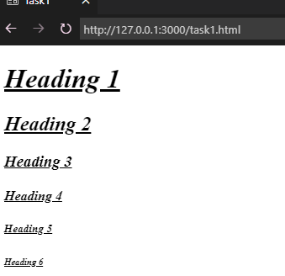
Task 2
<!DOCTYPE html>
<html lang="en">
<head>
<meta charset="UTF-8" />
<meta name="viewport" content="width=device-width, initial-scale=1.0" />
<title>Task2</title>
</head>
<body>
<h3>Italic Para</h3>
<p> <i>
Lorem ipsum dolor sit amet consectetur adipisicing elit. Sint earum
voluptate iste eveniet fugiat voluptatibus? Nisi exercitationem,
expedita nulla rerum ab dolorem quasi!
</i></p>
<h3>Bold Para</h3>
<p>
<b>Lorem ipsum dolor sit amet consectetur adipisicing elit. Sint earum
voluptate iste eveniet fugiat voluptatibus? Nisi exercitationem,
expedita nulla rerum ab dolorem quasi!</b>
</p>
<h3>Underline Para</h3>
<p> <u>Lorem ipsum dolor sit amet consectetur adipisicing elit. Sint earum
voluptate iste eveniet fugiat voluptatibus? Nisi exercitationem,
expedita nulla rerum ab dolorem quasi!</u></p>
</p>
This is hyperlink
<a href="https://classroom.google.com/">GCR</a>
<br />This is Image <br />
<img src="Screenshot 2024-09-05 093210.png" alt="Image" />
</body>
</html>

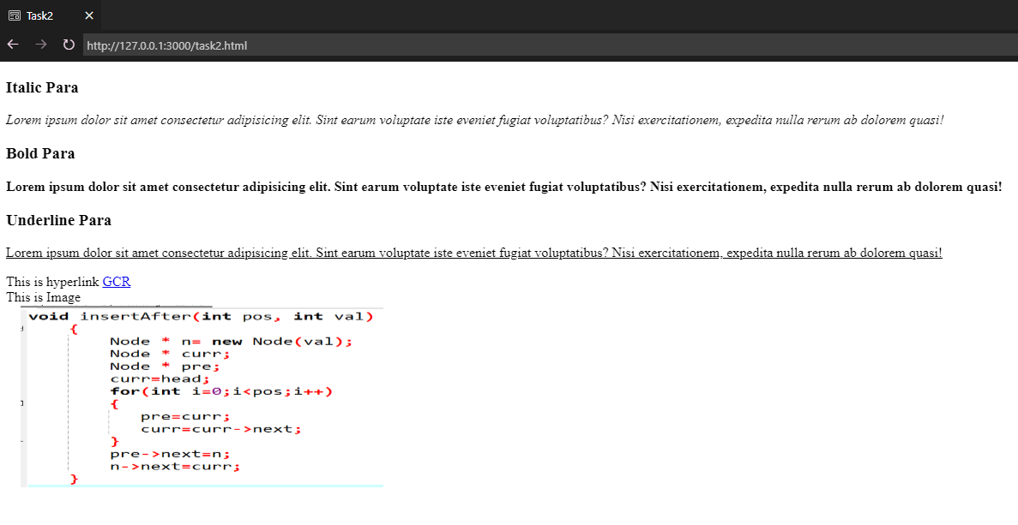
Task 3
<!DOCTYPE html>
<html lang="en">
<head>
<meta charset="UTF-8" />
<meta name="viewport" content="width=device-width, initial-scale=1.0" />
<title>Task3</title>
</head>
<body>
<h1>Courses Taught</h1>
<ol type="a">
<li>Web Programming</li>
<li>Discrete Structures</li>
<li>Electronic Commerce</li>
<li>Database Systems</li>
<li>Introduction to Computing</li>
</ol>
<h1>Nested List Example</h1>
<ol type="I">
<li>Web Programming</li>
<ul style="list-style-type: square">
<li>Autumn 2014</li>
<ol type="I" start="3">
<li>September - January</li>
<li>February-June</li>
</ol>

<li>Spring 2015</li>
</ul>
<li>Discrete Structures</li>
<ol type="i">
<li>Summer 2024</li>
</ol>
<li>Electronic Commerce</li>
<li>Database Systems</li>
<li>Introduction to Computing</li>
</ol>
</body>
</html>

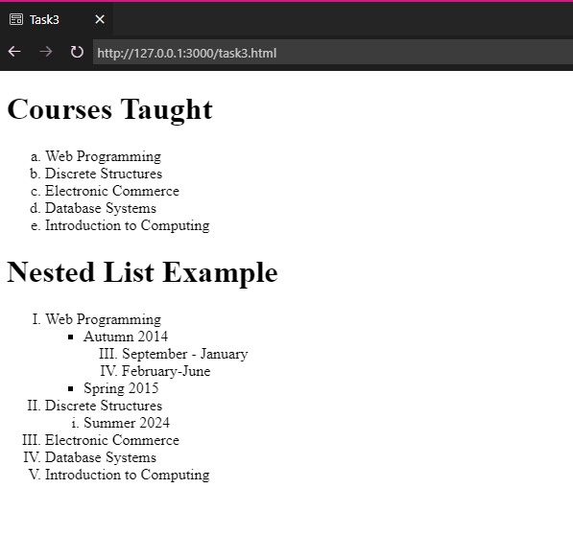
Task 4
<html lang="en">
<head>
<meta charset="UTF-8" />
<meta http-equiv="X-UA-Compatible" content="IE=edge" />
<meta name="viewport" content="width=device-width, initial-scale=1.0" />
<title>Task4</title>
</head>
<body>
<h1>Film Folk</h1>

<h2>Festival Diary</h2>
<p>
Here are some of the film festivals we will be attending this year.
<br>
Please
<a href="aa">contact us </a> if you would like more information.
</p>
<h3>January</h3>
<p>
<a href="aa">Sundance Film Festival</a> <br >
Park City,Utah, USA <br >
20-30 January 2011
</p>

<h3>February</h3>
<p>
<a href="aa">Tropfest</a> <br />
Sydney, Germany <br />
20 February 2011
</p>

<br />
<p><a href="aa"> About Film Folk </a></p>

<a href="aa">Top of Page</a>
</body>
</html>

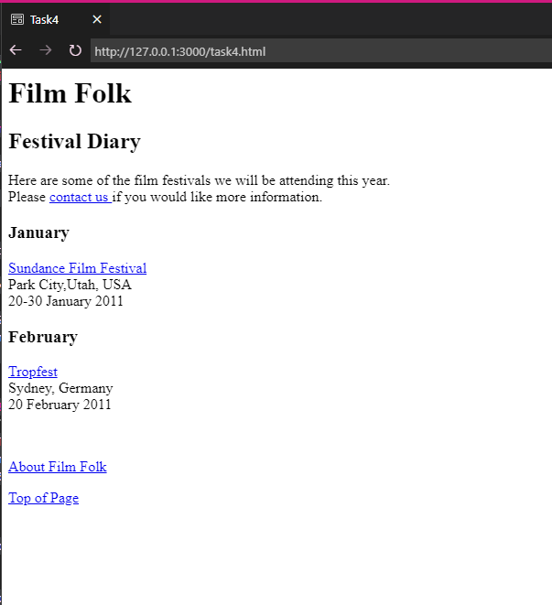
Task 5
<!DOCTYPE html>
<html lang="en">
<head>
<meta charset="UTF-8">
<meta name="viewport" content="width=device-width, initial-scale=1.0">
<title>Task5</title>
</head>
<body>
<img src="Capture.PNG" width="500 alt="">
<br>
<img src="Capture1.PNG" width="500" alt="">
<br>
This recipe for individual chocolate cake is so simple and so delectable!
<p>
<b>More Recipes:</b>
</p><br>
<img src="Capture3.PNG" alt="">
<img src="Capture4.PNG" alt="">
<img src="Capture5.PNG" height = 183 alt="">
</body>
</html>

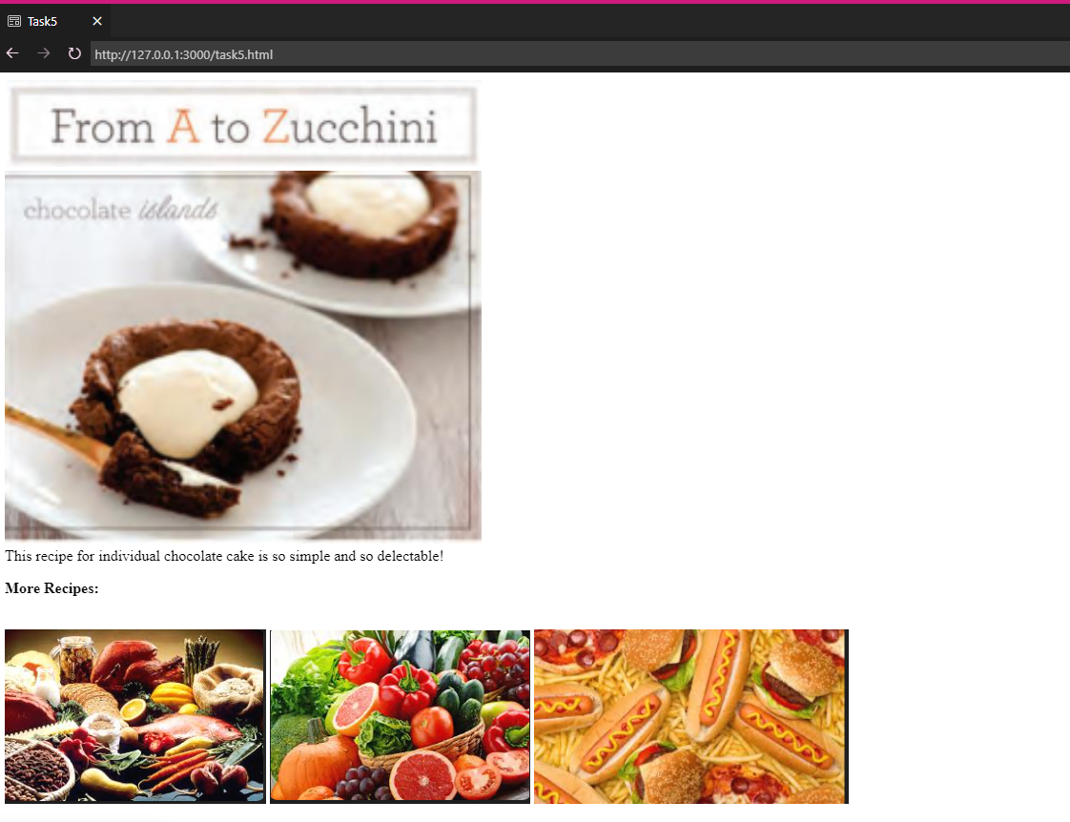
Task 6
<!DOCTYPE html>
<html lang="en">
<head>
<meta charset="UTF-8" />
<meta name="viewport" content="width=device-width, initial-scale=1.0" />
<title>Task6</title>
</head>
<body>
<p>
<center><h3>Laiba Fatima</h3></center>
<center>
k225195@nu.edu.pk | Phone: 0123456789 | Linkedin:
<a href="https://pk.linkedin.com/">Laiba Fatima</a> | Github:
<a href="https://github.com/">Laiba Fatima</a>
</center>
</p>
<hr>
<dl>
<dt>
<h4>Professional Sumary</h4>
</dt>
<dd>
Lorem ipsum dolor sit amet, consectetur adipisicing elit. Laborum quidem officiis sit expedita deleniti sed numquam, facilis, voluptatibus optio reiciendis iste, excepturi dolores fugit. Facilis magnam quod distinctio at minima ratione molestiae exercitationem expedita! Qui quo atque quas perspiciatis consequatur neque, delectus possimus animi blanditiis voluptatibus nam iste ratione aliquam.

<br>

</dd>
</dl>
<hr>
<dl>
<dt>
<h4>Education</h4>
</dt>
<dd>
<span style = "float: left"><I>NU-FAST </I></span>
<span style = "float: right"><I>Karachi, Pakistan </I></span>
<br>
Bachelors of Software Engineering

</dd>
</dl>
<hr>
<br>
<h4>Work Experience</h4>
<dl>
<dd>
<span style = "float: left;"><I>Amazon </I></span><br>
<span style = "float: right"><I>Dec 2024-Jan 2025 </I></span>

<ul>
<li>Lorem ipsum dolor sit amet, consectetur adipisicing elit. Officiis, adipisci et?</li>

<li>Lorem ipsum dolor sit amet, consectetur adipisicing elit. Officiis, adipisci et?</li>

<li>Lorem ipsum dolor sit amet, consectetur adipisicing elit. Officiis, adipisci et?</li>

<li>Lorem ipsum dolor sit amet, consectetur adipisicing elit. Officiis, adipisci et?</li>

</ul>
</dd>
</dl>
<hr>
<h4>Skills</h4>
<ul>
<li>Programming languages: Python, JavaScript, C++</li>
<li>Web development: HTML, CSS, JavaScript</li>
<li>Microsoft Excel, Word, Powerpoint</li>

</ul>
</body>
</html>

